INDIAN SCHOOL ALWADI ALKABIR
DEPARTMENT OF SOCIAL SCIENCE
Final Examination: 2022-23

CLASS: VIII Max: Marks: 80
Date: 08/03/2023 Time: 3 Hrs.
General Instructions: -
- Ensure that you have written your name and roll number correctly.
- This Question paper has three parts, Section A (History) B (Civics) and C (Geography).
- All questions are compulsory
- Attach the Map along with your answer script.
- All the answers must be correctly numbered as in the question paper in the Answer sheet provided.
SECTION - A (HISTORY) MARKS - 30
I | Multiple Choice Questions: - | 3 Marks
1 | Who implemented ‘the principle of Doctrine of Lapse’?  (a) Robert Clive (b) Dalhousie (c) Warren Hastings (d) None of these | 1 Mark
2 | The Viceroy who was responsible for the partition of Bengal  (a) Lord Curzon (b) Lord Ripon (c) Lord Mountbatten (d)William Bentinck | 1 Mark
3 | The leader who went on hunger strike to protect the interest of theTelugu speaking people in Andhra Pradesh:  (a) Chitta Ranjan Das (b) Potti Sriramulu (c) Krishna Menon (d) None of these | 1 Mark
II | Fill in the Blanks: - | 2 Marks
4 | Maratha kingdoms were located mainly in the ___________part of India. | 1 Mark
5 | The Vernacular Press Act was passed in ____________ | 1 Mark
III | Match the Following: - | 2 Marks
 | (i)Mixed Economy (a) Not to side any world power | 1 Mark
 | (ii)Non-alignment (b) Motilal Nehru | 1 Mark
 | (c) Private and Public sectors participate in production of industries and other spheres.
IV | Answer the following questions in one or two sentences: - | 3 Marks
6 | Who was the Mughal emperor who led to the Revolt of 1857? | 1 Mark
7 | What was the main aim of the Company before the territorial expansion? | 1 Mark
8 | What are the subjects included in the Concurrent Lists? | 1 Mark
V | Observe thefollowing pictures and answer the questions below: - | 4 Marks
9 | 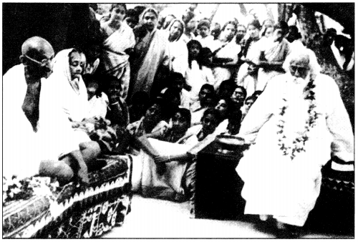  a. Along with whom is Mahatma Gandhi sitting in the picture.  b. What did Mahatma Gandhi feel about Education? | 2 Marks
10 | 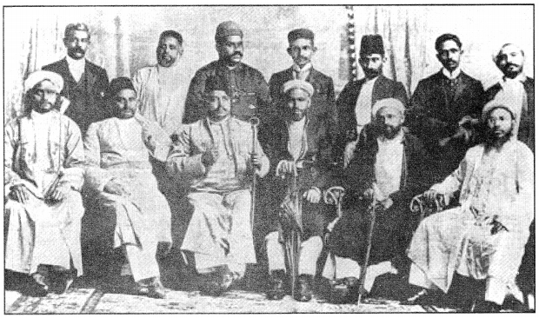  c. What does the picture shows.  d. What was the purpose behind the establishment of Natal Congress? | 2 Marks
VI | Answer the Following questions: - | 6 Marks
11 | Explain economic impact of the First World War in India? | 3 Marks
12 | What were the problems in unifying the people of India after Independence? | 3 Marks
VII | Answer in detail: - | 5 Marks
13 | A. What type of education did Mahatma Gandhi want in India?  OR  B. Why did Mahatma Gandhi want to teach children handicrafts? Why did he think that English education had enslaved Indians? | 5 Marks
VIII | On the given outline map of India, mark the important events and the sessions of Indian National Congress during the Freedom Struggle.  - The place where the Indian National Congress was established and met in 1885.  - The place where Gandhiji started the Satyagraha to support the peasants of Gujarat in 1917.  - The place which is associated with the calling off the Non-Cooperation Movement in 1922.  - The place where the Indian National Congress session was held under the presidentship of Sarojini Naidu in 1925.  - The place where the Indian National Congress session was held in 1927. | 5 Marks
SECTION - B (CIVICS) MARKS - 20
IX | Multiple Choice Questions: - | 3 Marks
14 | Which one of the following is a waterborne disease?  (a) Polio (b) Tuberculosis (c) Dysentery (d) Miseals | 1 Mark
15 | The act of keeping an accused in custody by the police is known as: -  (a) Cross-examine (b) Detention (c) FIR (d) All of these | 1 Mark
16 | The Adivasi language which has the largest number of speakers is  (a) Khasi (b) Manipuri (c) Santhali (d) Gondi | 1 Mark
X | Fill in the Blanks: - | 3Marks
17 | Public facilities are related to People's __________. | 1 Mark
18 | ____________ represents the interest of the state in the trial of a crime. | 1 Mark
19 | ____________ is a graded system or arrangement of persons or things. | 1 Mark
XI | Answer the following questions in one or two sentences: - | 4 Marks
20 | What are the sources of water in rural areas? | 1 Mark
21 | What does Right to Water mean? | 1 Mark
22 | What is meant by the term 'Ghettoisation'? | 1 Mark
23 | Name the communities who experience marginalization in India. | 1 Mark
XII | Answer the following questions: - | 5 Marks
24 | Why should the government bear the responsibility to provide public facilities to everyone? (Any two points) | 2 Marks
25 | Explain about the Justice Rajindar Sachar Committee Report? (Any three points) | 3 Marks
XIII  26 | Answer in detail: -  A. What is the role of police in investigating a crime?  OR  B. Write a brief note on the criminal procedure in the Criminal Justice System in India. | 5 Marks
SECTION - C (GEOGRAPHY) MARKS - 30
I | Multiple Choice Questions: - | 2 Marks
1 | The type of Farming to meet the needs of a family is known as-  (a) Subsistence Farming (b) Mixed Farming (c) Nomadic Farming (d) Organic Farming | 1 Mark
2 | A large number of people are migrating from this country to other parts of the world  (a) Sudan (b) Australia (c) New Zealand (d) None of these | 1 Mark
II | Fill in the Blanks: - | 1 Marks
3 | The city of ______________ is located in Japan. | 1 Mark
III | Match the Following: - | 3 Marks
 | (i) Rice a) Natural fiber
 | (ii) Jute b) Asia
 | (iii) highest populated continent c) China
 | d) Europe
IV | Answer the following questions in one or two sentences: - | 4 Marks
4 | Name the factors influencing the growth of agriculture. | 1 Mark
5 | What is Agricultural Development? . | 1 Mark
6 | What is an ‘age-sex pyramid’? | 1 Mark
7 | What is the general trend of migrations from one country to another? Why is it so? | 1 Mark
V | Answer in brief: - | 6 Marks
8 | Name the fiber crops and the climatic conditions required for their growth. | 2 Marks
9 | Which industry is often referred as the backbone of modern industry and why? | 2 Marks
10 | What is meant by ‘population composition’? | 2 Marks
VI | Answer the following questions: - | 6 Marks
11 | What is a population pyramid? Explain its significance and what information can it give? | 3 Marks
12 | 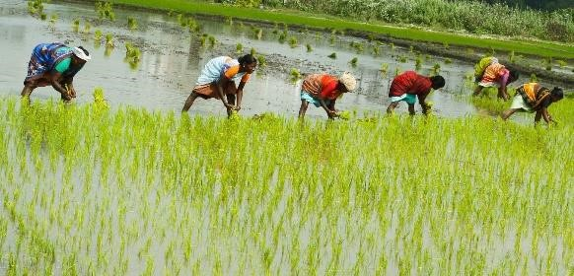  Observe the picture and answer the following questions below: -  a. Name the crop which is being planted.  b. Mention one benefit of Planting this crop in this method.  c. What are the climatic conditions required to cultivate this crop? | 3 Marks
VII | Answer in detail: - | 5 Marks
13 | A. Explain the classification of industries on the basis of size.  OR  B. Distinguish the followings: -  a) Agro-based industry and Mineral based industry.  b) Public sector industry and Joint sector industry. | 5 Marks
VIII | On the given outline Map of India, mark and color the following: -  (i) Iron distribution in the states of India- any two states  (ii) Major Bauxite producing states-any one state | 3 Marks

